

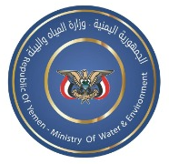

Project title: Enhancing Resilience of Agriculture and Food Security in Yemen

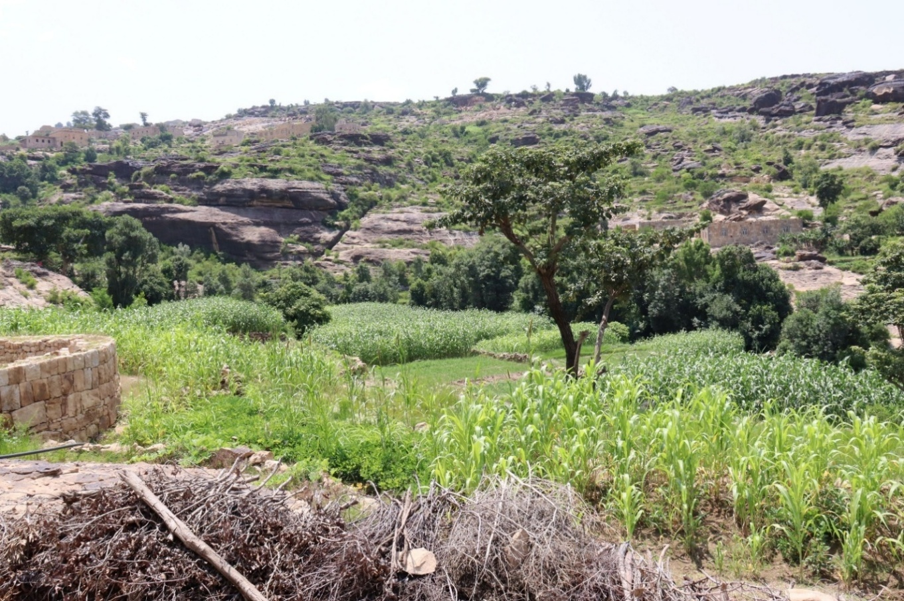
Project Progress as of 21 December 2025
Site visit to project locations in Al-Selw district, September 2025

Total Project Budget | US$ 500,000.00
Fund Utilization As of 30th Nov 2025 (Expenditure and Commitment) | USD 55,814.54
Project Duration | March 2025 - March 2026
Project Beneficiary | Targeted Beneficiaries | Beneficiaries Reached to date
Project Beneficiary | 500 | 400
Project Partner | Ministry of Water and Environment, Ministry of Agriculture, Irrigation and Fisheries, local authorities

Introduction/Brief Description:
Yemen’s acute food insecurity is exacerbated by climate variability and severe water scarcity. The project “Enhancing Resilience of Agriculture and Food Security in Yemen” which is funded by Japan Supplementary Budget (JSB), aims to improve the resilience and productivity of vulnerable smallholder farmers in Wadi catchment by increasing water use efficiency and stabilizing yields.
The project equips farmers with modern, water efficient irrigation technologies and climate smart agronomic practices; strengthens local institutions (AREA and the Offices of Agriculture and Irrigation) to translate CAMA meteorological data into actionable advisories. By reducing water use per hectare and improving on farm decision making, the project supports Yemen’s NDC commitments and contributes to more reliable local food supplies. This progress report summarizes results to date and the plan to complete remaining activities within the requested no-cost extension (NCE) period.
Project’s Progress as of 21 December 2025:
Country Output 1: Enhanced Climate Change Resilience for Livelihoods and Food Security.
Global Output 2: Accelerating adaptation in vulnerable and fragile countries and communities, for increased resilience to climate risks and impacts.
2.1. Implement adaptation and risk reduction actions, including ecosystem-based adaptation, coastal adaptation, climate-resilient agricultural practices, adaptation in high-mountain ecosystems due to glacier melting, early warning systems, etc. and ensure they are available in fragile settings and to marginalized groups.
Planned Activities | Planned Targets | Progress | Remark
Activity: 1.1  Define water-efficient irrigation technologies that are appropriate for the Tuban area in consultation with counterparts and farmers. | 80 | 400 farmers have been surveyed and validated through site visits, data collection, assessments, and planning activities as part of the verification process. These steps were essential to ensure accurate beneficiary targeting, technical feasibility, and compliance with the project’s selection criteria, laying the groundwork for effective implementation. The final lists of beneficiaries and site locations are endorsed by the authorities. | The implementation timeline was significantly affected by multiple external and institutional constraints that emerged throughout 2025. The primary disruption to the project implementation was caused by the catastrophic impact of unprecedented flash floods that struck Lahj and Taiz during June-October period which damaged roads, irrigation canals, and agricultural terraces. This has triggered safety-driven stop work orders, suspension of field level activities, and cancellation of planned field missions.  The second setback resulted from the competition over the leadership position of the district director and the attempts by district administration to influence the scope of the project and selection of beneficiaries.  As a result of the small agricultural holdings, the project beneficiaries and sites have increased remarkably which have resulted in a long verification process of both beneficiaries and sites. Similarly, the detailed technical assessment for all these sites and beneficiaries took longer time than planned.
Activity: 1.2  Implement water-efficient irrigation technologies for farmers in Tuban | 20 Ha | The number of project beneficiaries and sites has increased. As a result, the actual hectares to be covered by the project will reach 30 Ha, with 10 additional hectares compared to the planned target.  The announcement for the pre-qualification of suppliers and contractors to supply and install modern irrigation systems in both districts has been completed. The evaluation process is currently underway to identify a shortlist of qualified vendors who will subsequently be invited to submit their technical and financial proposals. The evaluation has been finalized.  Standardized Bills of Quantities (BOQs) and technical specifications have been prepared for Al-Selw district while they are being finalized for Al-Mosaymer district. Once completed, these BoQs and technical specifications will be incorporated into the bidding documents.  Coordination with the Water User Associations and local authorities was made to formulate operation and maintenance committees in each targeted location: 8 locations in Al-Mosaymer district and 6 locations in Al-Selw district. | The delay experienced in the first activity has affected the start of this activity.  Furthermore, due to the large number of targeted locations and beneficiaries, the project had to establish operation and maintenance committees in targeted locations which has also taken time to finalize.
Activity 1.3  Train small-holder farmers on climate-resilient production practices, emphasizing the need to adapt their crop calendars by adjusting planting and harvesting dates in response to changing climate conditions. | 200 | In collaboration with the Agriculture Research and Extension Authority (AREA) and the offices of Agriculture and Irrigation, the Project has conducted training needs assessment for farmers and training materials are currently being developed. The Beneficiary farmers were also selected in a participatory manner. | Due to the delays in Activity 1 and 2 above, this activity has experienced some delays. Further, some coordination challenges were experienced with the AREA and Offices of Agriculture and Irrigation relating to the training needs assessment and training materials development. To overcome this, the Agriculture and Irrigation Offices were engaged to carry out the training needs assessment surveys while AREA will develop the training materials and conduct the trainings.
Activity 1.4:  Develop and disseminate climate change adaptation communication materials among target communities | 500 | The Project established a communication channel among AREA, Office of Agriculture and Irrigation, and Civil Aviation and Meteorological Authority (CAMA). A draft protocol for climate-data exchange in user-friendly formats for farmers has been developed. Preparations for the Training of Trainers (ToT) on interpreting agrometeorological data, translating CAMA’s meteorological outputs into practical climate advisories, and creating simple climate messages tailored to farmers’ needs are being finalized and the first training is planned to be conducted in December 2025. The first training will be conducted for institutions covering Al-Mosaymer, Lahj, including relevant national level institutions, while the second training will be conducted to cover institutions in Al-Selw, Taiz. | This activity has experienced delays due to the non-availability of historical climate data in CAMA in the IRG controlled areas which in turn impacted their ability to share historical agrometeorological data with AREA and farmers. To overcome this challenge, informal coordination was made with experts in de facto controlled areas to provide historical climate data and prepare training materials. Furthermore, AREA has capacity limitations in interpreting and translating agrometeorological data to simple climate and adaptation messages tailored to farmers’ needs. This has been overcome by ensuring the preparation of detailed training materials to address all these gaps in these institutions.

Challenges and Risks:
- Identifying a qualified and experienced partner that is able to navigate through contextual challenges and a wide array of stakeholders with diverse interests to implement the project was a challenge. To mitigate this challenge, UNDP mapped out potential partners and conducted consultations with the MoWE. It was important to select a partner that has experience in implementing such types of projects while being able to ensure smooth coordination with the governorate, district, and sub-district level authorities and executive offices. The Project Management Unit of the MoWE was identified as best suited to implement the project.
- The project encountered coordination challenges with various authorities, particularly at the governorate, district, and sub-district levels. Some of these entities attempted to influence the selection process for target locations and beneficiaries. To address these challenges, the project actively engaged the Project Management Unit of the Ministry of Water and Environment in the implementation process. Clear and specific criteria were developed to guide the selection of both target locations and beneficiaries.
- Several institutions including the agricultural offices, CAMA, and AREA insisted on being part of executing project activities. To address this challenge, the project exerted efforts to engage them in activities relevant to their mandate. Senior officials from the MoWE, MoAIF, as well as representatives from the two districts were engaged to support resolving this challenge.
- Some of the proposed farms identified for the installation of modern irrigation systems in Al-Mosaymer and Al-Selw districts lack sustainable, climate-resilient water sources. These areas face limited water availability and rely on outdated water storage infrastructure, posing a significant challenge to the effective deployment of modern irrigation technologies. To address this challenge in Al-Mosaymer, the irrigation systems will be connected to solar-powered boreholes supported by the German-funded project. In Al-Selw, the systems will be linked to rehabilitated water storage ponds under the same project, ensuring a more reliable and climate-resilient water supply for irrigation.
Implementing Partners:
Project Management Unit of the Ministry of Water and Environment (MoWE), Ministry of Agriculture, Irrigation, and Fisheries (MoAIF), Agriculture Research and Extension Authority (AREA), Civil Aviation and Meteorological Authority, Agriculture and Irrigation Offices, and Water User Associations (WUAs).

Photos:
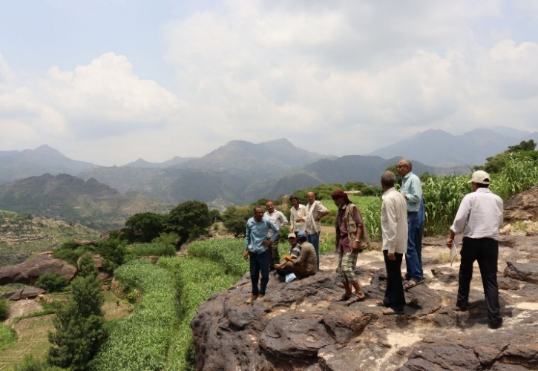 | 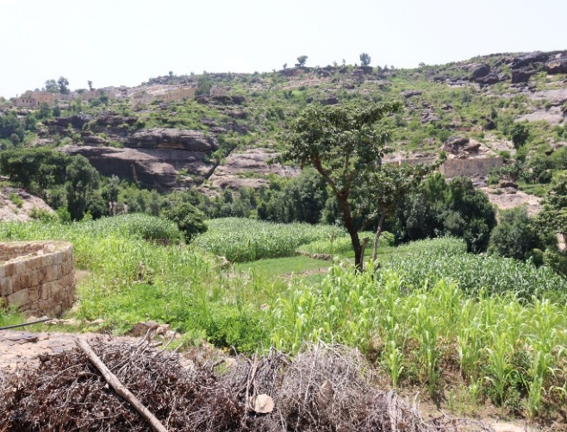
Field visit by the project team to Al-Selw district to inspect potential intervention sites
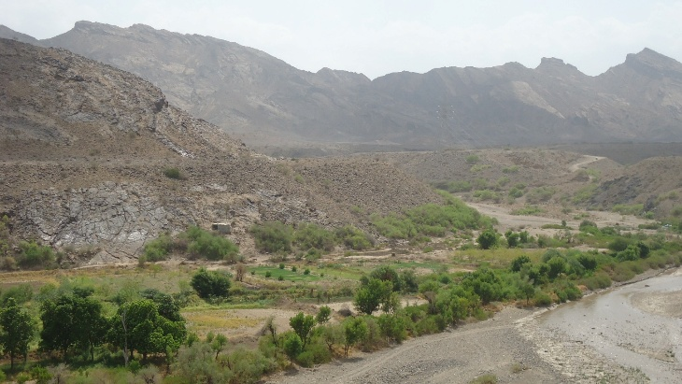 | 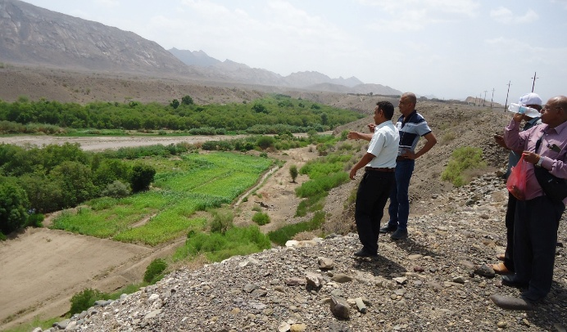
Field visit by the project team to Al-Mosaymer district to inspect the potential intervention sites
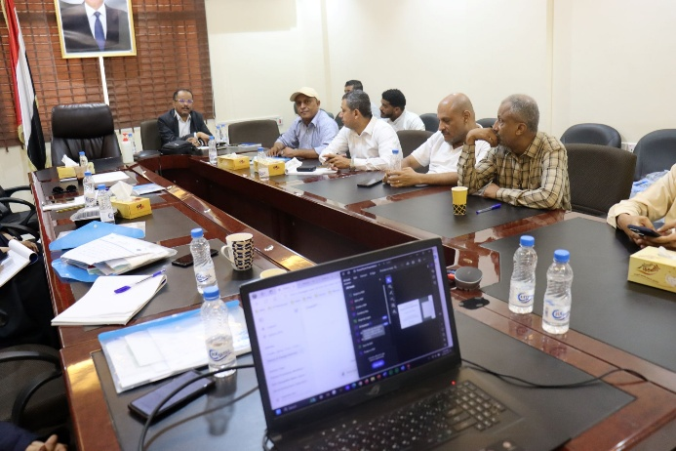 | 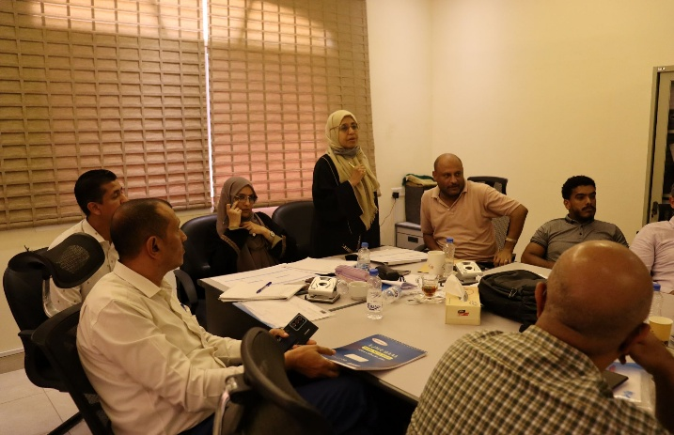
Coordination workshop with MoWE and MoAIF to ensure support to the project
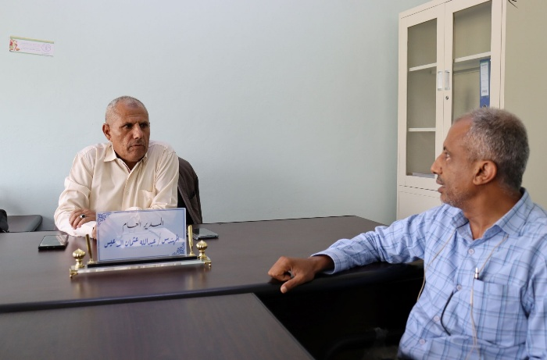 | 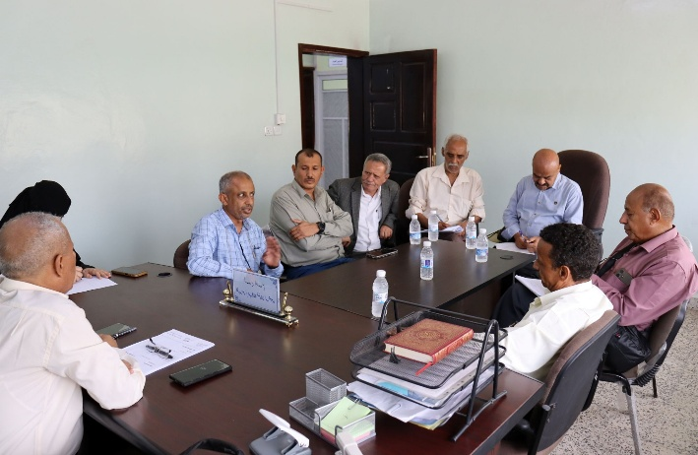
Coordination meeting with the Agriculture and Irrigation Office in Taiz
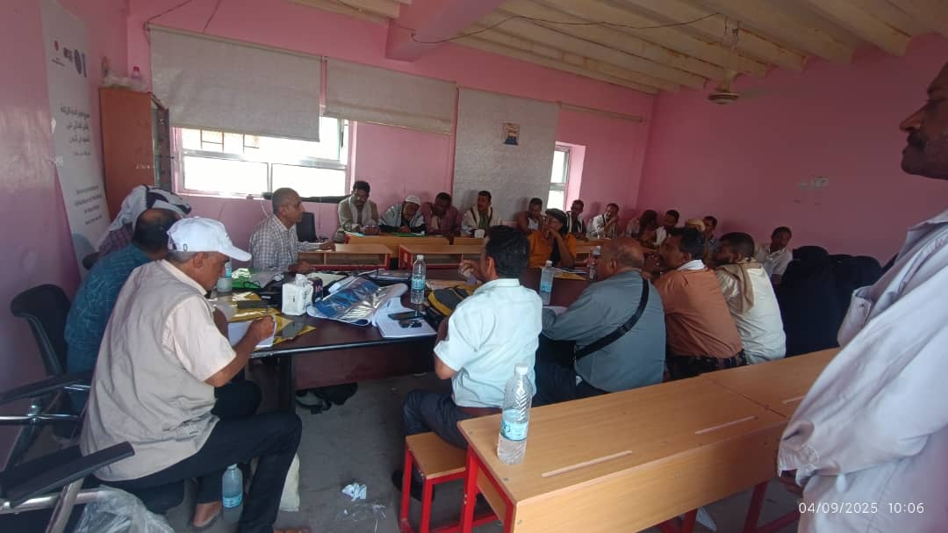 | 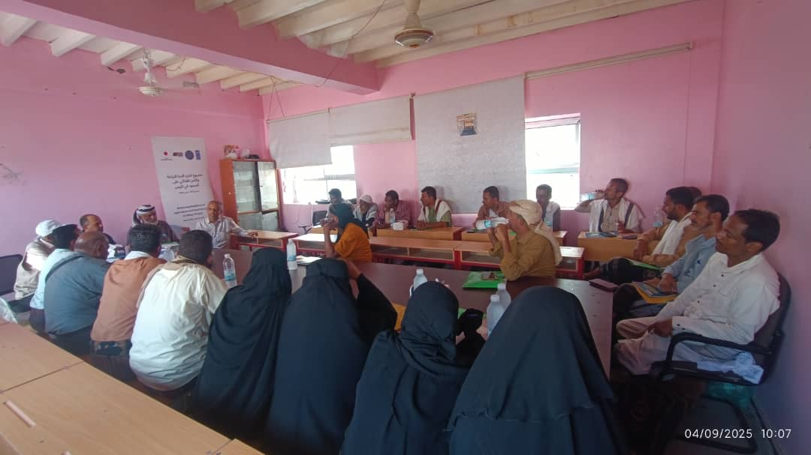
Al-Mosaymer Inception Workshop
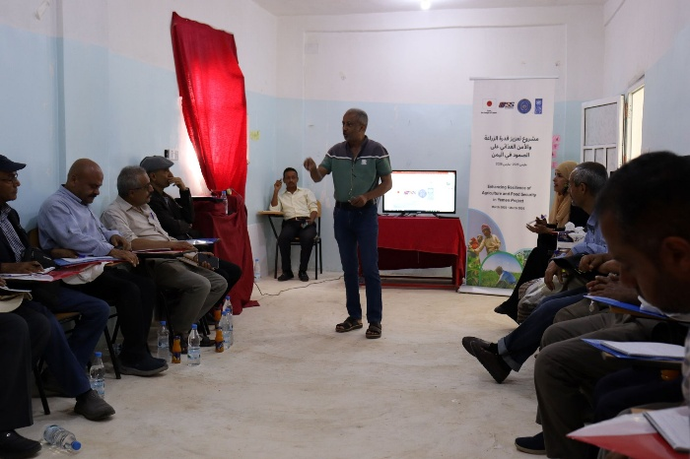 | 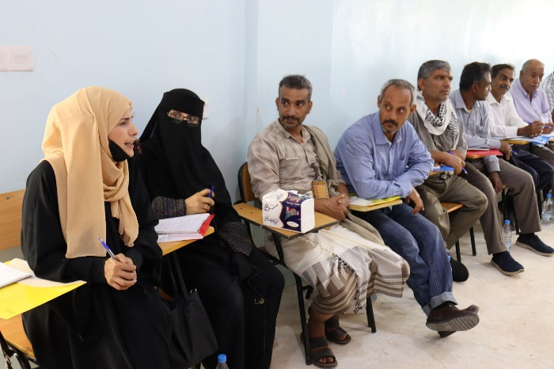
Al-Selw Inception Workshop
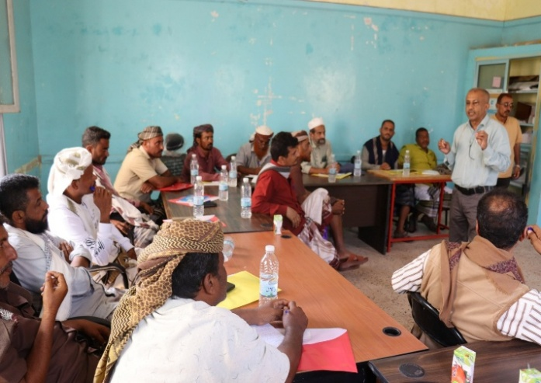 | 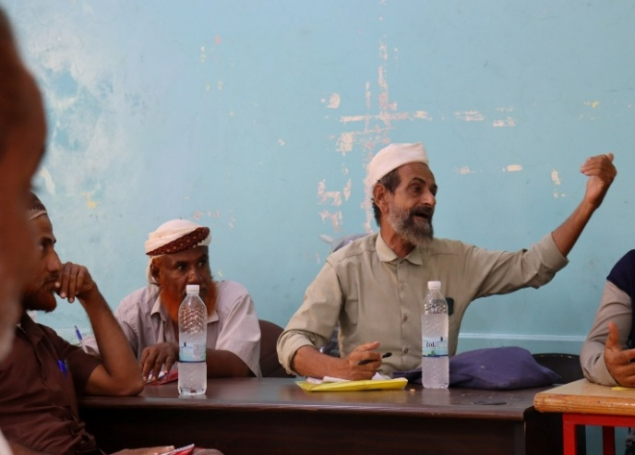
Al-Mosaymer beneficiary and site Validation Workshop
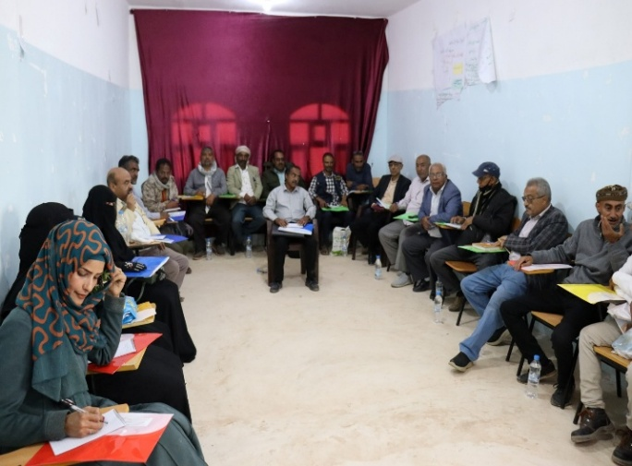 | 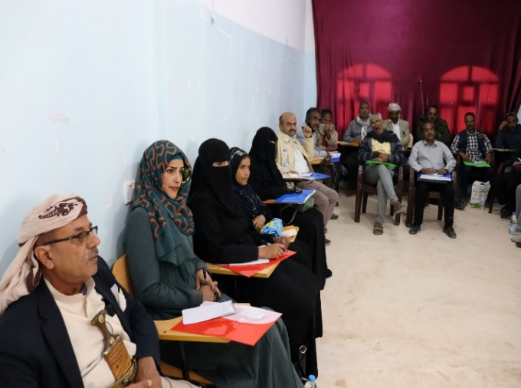
Al-Selw beneficiary and site Validation Workshop

